Chur Language Reference Manual
Whilst all reasonable care has been taken to ensure that the details are true and not misleading at the time of publication, no liability whatsoever is assumed by Automature LLC, or any supplier of Automature LLC, with respect to the accuracy or any use of the information provided herein.
Any license, delivery and support of software require entering into separate agreements with Automature LLC.
This document may contain confidential information and may not be modified or reproduced, in whole or in part, or transmitted in any form to any third party, without the written approval from Automature LLC.
Copyright © 2012 Automature LLC
All rights reserved.
Revision History
Version | Date | Name | Description of Changes
1 | 11/09/10 | Nitish Rawat | First Edition
2 | 08/30/11 | Sankha Sil | Revision
3 | 09/16/11 | Sankha Sil | Revision
4 | 11/04/11 | Sankha Sil | Revision
5 | 02/13/12 | Sankha Sil | Revision
6 | 02/15/12 | Debabrata Das | Second Edition
7 | 03/23/12 | Dipu Deshmukh | Review
8 | 23/04/12 | Sankha Sil | Revision (Named Argument description updated, test results reporting updated)
9 | 16/05/12 | Sankha Sil | Revision (Arranging and adding new features of ZUG)
10 | 19/06/12 | Sankha Sil | Review
11 | 03/07/12 | Dipayan Sengupta | Revision (Added examples for NameSpaces)
12 | 14/08/12 | Sankha Sil | Built-in Atoms added
13 | 25/10/12 | Dipayan Sengupta | Added a new Chapter for MVCV
14 | 13/11/12 | Sankha Sil | Revision(Correcting Indexed MVM examples)
15 | 21/11/12 | Sankha Sil | Added new feature: Built In Atom enhanced.
16 | 21/01/13 | Md Sarfaraz Khan | Added a new topic,command line options

Table of Contents
1. Introduction 6
1.1 Document Purpose 6
1.2 Intended Audience 6
2. Anatomy of an Automation Test Suite 7
2.3 TestCases and Molecules Worksheets 9
2.4 Prototypes 13
3. Writing a simple Test Case 14
3.3 Flow of Execution 14
3.4 Command line execution 15
4. Built-in Atoms 16
4.1 Context Variable Atoms 16
4.2 XML Parsing Atoms 18
4.3 Web Automation Atoms 18
4.4 Print Atom 18
4.5 GetValueAtIndex Atom 18
4.6 GetCurrentIndex Atom 18
4.7 GetValueAt Atom 19
5. Exception Handling 20
5.1 Test case or Molecule exception handling 20
5.2 Test suite exception handling 21
6. Context variables 22
6.1 Definition 22
6.2 Declaring a Context variable 22
6.3 Pass arguments by value or by reference 22
6.4 Reading and Altering Context variable value from atoms (ZUG API) 22
6.5 Zuoz pearls 23
6.6 Appending values to a Context variable 23
6.7 Destroying a Context variable 23
6.8 ZUG test environment variables 24
7. Molecules 26
7.1 Definition 26
7.2 Designing a Molecule 26
7.3 Positional and named arguments 27
8. Multi-valued Macros 30
8.1 Definition 30
8.2 Cartesian MVM expansion 30
8.3 Indexed MVM expansion 30
8.4 Nested MVMs 31
8.5 MVM used in Test-cases 31
8.6 MVM used in Molecules 32
8.7 Scalar and Vector MVMs 32
8.8 Indexing Macro values in a molecule without Indexed MVM 33
9. Multi Valued Context Variable 34
9.1 Definition 34
9.2 Cartesian Expansion 34
9.3 MVCV used in Test-cases 35
9.4 MVCV used in Molecules 35
9.5 Scalar and Vector MVCVs 36
10. Concurrent Execution 37
10.1 Test case or Molecule concurrency 37
10.2 Test step concurrency 37
10.3 Thread safe context variables 37
10.4 Passing thread safe context variables as arguments 37
11. Negative Testing 38
11.1 Definition 38
11.2 How To Use 38
12.NameSpaces 40
12.1 Calling a Molecule from a single external worksheet. 40
12.2 Calling external macros from an external worksheet. 41
12.3 Calling two different macros from different external worksheets. 41
12.4 Multi Level Include Files 42
13. Command Line Options 43
13.1 -verbose 43
13.2 -include 43
13.3 -macrocolumn 43
14. ZUG Logs 45
14.1 Result Log 45
14.2 Debug Log 45
14.3 Error Log 45
14.4 Primitive Log 45
15.Using External Atom Framework(Atom Libraries) 46
16. Reporting test results 49
17. Glossary 50

1. Introduction
CHUR is Automature's formal test specification language. CHUR needs ZUG to execute tests, so please refer to the ZUG manual to find out how to run tests written in CHUR.
CHUR is platform independent. It can execute tests wherever ZUG is supported.
CHUR uses a spreadsheet paradigm to specify test steps. The choice is intentional. Most test engineers aleady use spreadsheets to document testcases. CHUR is simply a more formal way to describe such tests, so that they can be executed automatically.
CHUR is simple in structure, but extremely powerful as a test specification language. With semantic support for concurrent execution, threadsafe context variables, macros, include files, testcase generation, explicit differentiation between test steps and verification steps, and other features, it is not just yet another general purpose programming language. Instead, it is specifically designed to make the design and maintainability of test cases easier.

1.1 Document Purpose
This Programmer’s Guide guides the user through the steps to create a testsuite in CHUR, containing one or more test-cases. This document describes the various features of the language, and provides examples of how they are intended to be used.

1.2 Intended Audience
This user manual is intended for users who want to learn designing test cases using CHUR. It may also be used by quality analysts, test automation engineers, QA managers, QA architects to understand the basic concepts behind Automature's unique solution to Automation.
Though no formal programming background is essential to understand CHUR, some prior basic knowledge of programming concepts, spreadsheets and software testing, would be helpful.

2. Anatomy of an Automation Test Suite
Automation Test Suite is represented in spreadsheet and it consists of following worksheets:
Config, Macros, TestCases, Molecules and Prototypes

2.1 Config Worksheet
This section is where environmental information is described. This information is typically used by ZUG to locate supporting programs, and upload results into the Automature database.
It also contains the configuration for mapping where the Atoms are installed and also if any other spreadsheets need to be included or not.

Following is a brief description of the Config Sheet properties –
Property Name | Property Significance | Values | Optional?
ScriptLocation | Here the location of the atoms are specified. ZUG will pick the atoms to execute from the location specified. Multiple location may be provided using ‘;’ after each qualified path.  The locations can be a fully qualified path name, or a path relative to the current directory. | e.g. E:\ZUG\Scripts\ is a valid fully qualified path for ScriptLocation whereas "Scripts\Atoms" is a relative path and it will find the folder either from the current location or the location of the testsuite as per the ZUG invocation. For Multipile Atom Locations e.g C:\Zuoz\Atoms\Java;C:\Zuoz\Atoms\Ruby | If no external atoms are userd then this field can be kept blank.
DBHostName | Host name of the Database server | HostMachine :port<localhost:4567> | No
DBName | Database Name | Framework (not mandatory for davos) | No
DBUserName | Name of the User to do Authentication to DB | e.g. davosuser | No
DBUserPassword | Password of the user required for SQL Authentication | e.g. user | No
Test Suite Name | Name of the Test Suite | e.g. ZERMATT Automation | No
Test Suite Role | Role of the node where Test Suite will be executed | e.g. client , server , etc...). | No
ProductLogLocations | List of folders (Fully qualified paths) of logs for products under test like ZUG Client, Zermatt server | This should be a comma separated list of paths | Optional
INCLUDE | Allows a reference to another spreadsheet file, which contains Molecules and macros to be included. ZUG allows more than one such declaration and nested include files. | e.g. C:\FileOps.xls  e.g for multipile includes C:\MoleculeFile.xls,C:\MacroFile.xls | Optional

2.2 Macros Worksheet
This section allows the test case designer to declare short names called Macros that can then be substituted in the test case specification during execution. This information is integral to the logic of the decomposed test steps, and does not relate to the execution environment.
There are three columns on the Macros worksheet:
Column Name | Significance | Values | Optional?
Macro Name | The first column is for the Macro Name. | A Macro name must start with a single dollar ($) . A Macro name can contain letters, numbers or underscores ( _ ). | No
Value | The second column contains the value assigned to the Macro. | Any string, e.g. HostMachine :port<default 3306> | No
Comment | The third column is for comments. | Any related information to the Macro, something that describes the Macro or its purpose or any comment can be written here. This column is ignored by the engine and therefore, isn't mandatory. | Yes

A sample Macro worksheet:
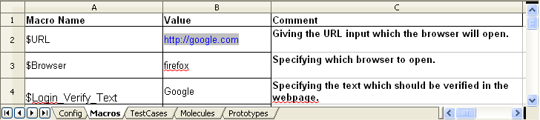

2.3 TestCases and Molecules Worksheets
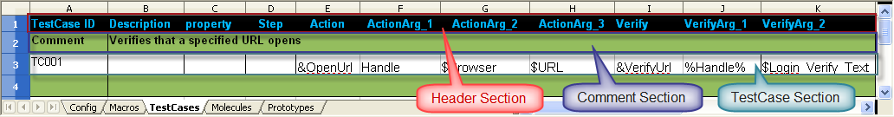
The Test Case and the Molecules worksheets are divided into two logical sections, viz.
- Header Section - The first set of rows in each sheet.

The following is the header section for a test case sheet:

- One or more of the following two sections
  - The comment section - this section will appear as a preamble to a testcase, and is a verbose description of the testcase
  - The testcase section, which lays out the details about steps, actions and verifications about an individual testcase. This section is divided into three logical column groups, viz.
    - The identification group of columns
    - The test step group of columns, and
    - The result verification group of columns
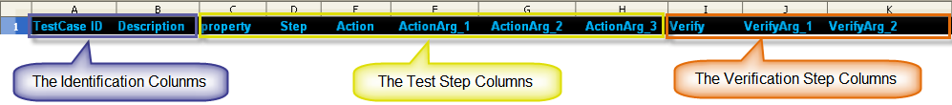

The identification group of columns
These columns identify the test case.
- The first column contains the testcase or the Molecule identifier. This must uniquely identify each test case. This identification is used to locate the row in the test framework database, where results will be stored.
- The second column should contain a summary description of the testcase.
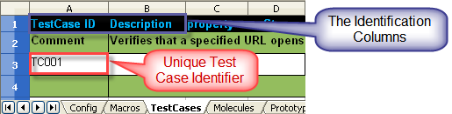

The test step group of columns
These columns describe the steps involved in executing the test. A test is expected to consist of one or more actions. Actions may be performed in sequence or in parallel. The step identifier allows the designer to designate several steps to be executed in parallel. Each action step allows the specification of input arguments.
The sequence identifier also allows the designer to declare certain steps to be initialization or cleanup steps. By appropriately pairing the sequence identifiers for these steps, the designer can tell ZUG which cleanup steps need to be executed, in case the test fails at any given point.
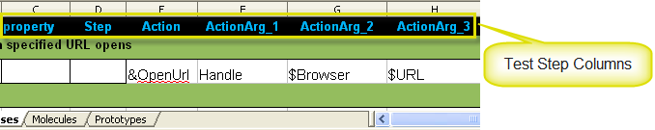
The result verification group of columns
These columns describe how to verify the outcome of a specific action. Each method can be supplied arguments. The verification method always returns a status. If the status returned is a zero, then the verification is deemed to have succeeded. If all actions for a given test case are successful, then the testcase has passed.
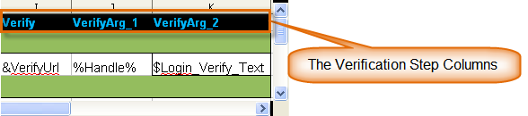
The following table describes the meaning of indiviudal columns in the testcases & Molecules worksheet.
Column Name | Column Description | Acceptable Values | Optional?
TestCase ID* or *Molecule Name | Unique identifier or name for a test case, or Molecule. The cell should be left blank if the action on the corresponding row is a part of the same test case or Molecule declared earlier. Init and Cleanup are reserved names interpreted by the ZUG in a special way | Init : This is the initialization Molecule for the entire test plan. If a testcase is named Init, ZUG will execute this testcase before any test case is executed from the test case worksheet. If all action steps for Init succeeds, ZUG will proceed with other test cases. The result of init is not stored in the database. If this fails then ZUG looks for a testcase named cleanup  Cleanup : This is the clean up for the entire test suite. The cleanup testcase is executed at the end after all the test cases have been executed. Like the Init testcase, the result for the cleanup Molecule is also not stored in the database. | Mandatory, if the row corresponds to the first step of a test case, Molecule, initialization or cleanup. Otherwise, should be left blank
Description | Textual Description of the Step. | Currently ignored by the ZUG, it is a good practice for the Test Case Writer to document the intent of the step within the Test Case or Molecule. | Optional, but highly recommended
property | This column is used to tell the ZUG how to execute the action or the testcase. The property can be a testcase or Molecule property, or it can be a test step property. Multiple properties can be specified as a pipe separated list | - Auto or Manual : (test case or Molecule property) . Means that the test case or Molecule will be executed by the ZUG.  - GCE or Seq: ( Test case or Molecule property) : GCE stands for "Generate concurrently executing testcases" - This means All the expanded test cases (using MVM) will be executed concurrently (i.e. in parallel) instead of sequentially.  - REM/Comment or Exec; (test step property) To prevent a specific step (Action/Verification step) from execution.  - Negative,neg-action,neg-verify for negative testing. | Default properties:  Auto | Seq | Exec
Step: | This should be specified for each Action of a Test Case or a Molecule (but) not for a Verification step. It should be a monotonically increasing number for each test case action. If multiple steps of a test case have the same number, then those steps are executed concurrently.  Some steps can be considered to be initialization steps, a few others the actual action steps, and the rest cleanup steps. The initialization steps should be postfixed by an "i" and the cleanup steps should be postfixed with a "c". This allows ZUG to handle exceptions properly, without the necessity to have a semantic understanding of the actions. | "2i" and "5c" are examples of a valid initialization step and a valid cleanup step | Optional, unless two steps are supposed to be executed in parallel, or are used to pair an initialization step with a cleanup step within a test case or Molecule.  The default behavior, when steps are not numbered are that the steps are exceuted sequentially.  Only those cleanup steps of a testcase or Molecule will be executed, whose initialization steps have been completed or started.
Action | A Test Case is a sequence of one or more Actions. And each Action may take as many arguments as necessary. | "@" : prefixes the name of a atom. ZUG executes the Action by executing the atom in a separate command shell window. The atom must return a status value indicating success or failure. A zero return indicates success. An non-zero return will cause the testcase or Molecule to abort, and initiate cleanup actions.  "&" prefixes the name of a Molecule. ZUG supports the notion of Nested Molecules - wherein a Molecule or a normal testcase can refer to a series of Molecules, which can then invoke any number of other Molecules. Note that recursive Molecule calls are not supported.  Built-in atoms (no prefix) - These are atoms that execute in the same process context as ZUG. These atoms are internal to the ZUG For a complete list of built-in atoms, see Built-in Atoms .  In-Process atoms (no prefix) – Atoms may also be added by users to execute in-process. The name of the library must precede the name name of the atom.
ActionArg_# | All Action Arguments should have "ActionArg_#" as a caption for the column header, where # should be an integer, starting from 1 and be incremental. For example to have 3 arguments for the Action one can have 3 columns with the column caption reading "ActionArg_1", "ActionArg_2", "ActionArg_3". The contents may be an actual value, a macro, that would be substituted at "compile" time, or a context variable, that would be substituted at "execution" time. Refer to Macro description to learn about macros. Action arguments also support passing of named formal arguments e.g. Formal_arg1=Actual_arg1. Actual_arg1 may be an actual value, a context variable or a macro. While passing an argument from a test case to a molecule, only the value is passed (and not the formal name). However, if the action happens to be an atom, (action name prefixed by @, the arguments are passed as a formal name=actual value pair.). Formal Arguments increase the maintainability of the testsuite. | The contents may be an input argument, referred to by its position, or its formal name, or an actual value, a context variable, or a macro that would be substituted at execution time.  Context variables may be passed by reference or by value. If a context variable is referenced enclosed within a pair of '%' around it, the variable is passed as by value, otherwise ZUG just passes the context variable by reference and the atom, or Molecule is responsible for reading or setting the value of that context variable  Pass By Value :  Example: @openbrowser URL=%myurl%  Pass By Reference :  Example: @getwindowhandle WHandle=WINDOW_HANDLE | Optional
Verify | Each Action of a Test Case may consist of none, one, or several Verification Methods. And each Verification method may take several arguments as needed. | Any verification method that starts with a "@" will be considered a atom. ZUG will execute the Verification Method by running the atom in its own command shell window. A Verification Method may also invoke a Molecule.  Note that verification methods may also be implemented as in-process atoms. In that case, the name of the atom must be prefixed with the package name, in which the atom is implemented. In process atoms should not be invoked using the :@” prefix. | Optional
VerifyArg_# | All Verification Arguments should have VerifyArg_# as the column caption, where # must be a number (integer). This number must be incremental. For example to have 3 arguments for the Verification Method, one must have 3 columns with the column captions VerifyArg_1, VerifyArg_2, VerifyArg_3 respectively. | The contents may be an input argument, referred to by its position, or its formal name, or an actual value, a context variable, or a macro that would be substituted at execution time.

2.4 Prototypes
This is the place where one specifies the footprint (i.e. the number and names of formal arguments of invokable entities) for atoms and molecules. This allows ZUG to perform syntax verification.

Specifying prototypes for molecules or atoms is optional. It is generally good practice to do so, because ZUG can automatically do compatibility checks between different versions of molecules, perhaps packaged inside include files.

3. Writing a simple Test Case

3.1 Introduction

To write test cases, you should copy the template spreadsheet file (Testsuite_template.xls) from the templates folder of your ZUG installation directory. Test cases are written in the TestCases worksheet of the spreadsheet and the spreadsheet with all its test cases is called a test suite.

The TestCases worksheet of the spreadsheet has a number of columns. For ZUG to execute a test case, the first row in the TestCase ID and the Action columns cannot be empty. Test cases are separated by the green rows, which contain a description of the intent of the test cases, and each test case must contain at least one row.

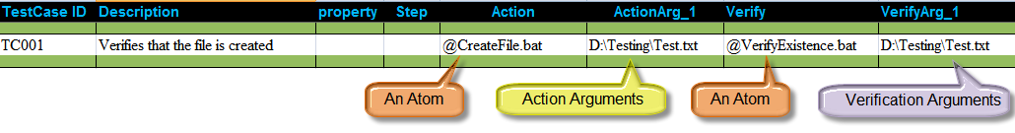
The above test case shows how to create a file and also verifies whether the file is created or not.

3.2 Action/Verification steps and their arguments

A test case in CHUR consists of one or more Action steps and their corresponding verification steps.
To write an automated test case you need to write action steps in the Action column and verification steps in the Verify column.

These action steps can be references to Atoms or Molecules. We shall use only Atoms for the Action and Verify steps in this section.

- An Atom is a user-written program or a CHUR built-in or user-extended function, that implements a very specific task e.g. open an application, click a button, save a file, navigate to a webpage, etc.

Atoms accept arguments just like any other program or function. Arguments can be plain text, Context Variables or Macros. Macros that contain some value and are defined in the Macros worksheet.

- A Macro is a name given to a constant string value (text). Macros are defined in the Macros worksheet and the values are replaced at runtime in the TestCases and Molecules worksheet of the spreadsheet wherever the corresponding Macro names are used.

3.3 Flow of Execution

ZUG starts to execute test cases on the Testcases worksheet of the spreadsheet in the order they are defined.

ZUG executes the Atom in the Action column of the test case by passing the argument list to the Atom and launching the Atom using the interpreter defined in the ZugINI.xml file and then it executes the Atom in the Verify column by passing the argument list, if any, to it.

The default flow of execution of a test case is sequential, i.e. row by row. That is, first the Action step is executed and then its verification step, if any, is executed, which is in the same row of the Testcases worksheet. Once both the Action and Verify step are executed of the first row of the test case, the control jumps to the second row of the test case, if any, and starts to execute the Action and Verify steps and so on.

3.4 Command line execution

In order to execute your testsuite from command line you should type the following on the console:

C:\>runzug C:\Testsuites\Template.xls -verbose

runzug is the command to launch ZUG from command line, the second argument is the path to your testsuite file and the third argument -verbose tells ZUG to show the detailed output of the executiion of the test suite.

4. Built-in Atoms
There are some atoms which are internally included in ZUG and can be used just like other Atoms in CHUR test suite. These atoms are often referred to as built-in atoms. To invoke built-in atoms refer to them without the usual “@” prefix.
Built-in atoms execute in the same process context as the engine that drives the test cases. Therefore they are significantly less expensive to invoke, than out-of-process atoms.
CHUR also supports user-written atoms that are executed in the same process as the engine. Currently, only atoms written in Java, can be invoked as in-process atoms. To invoke these atoms, the name must be prefixed with the name of the package in which they are contained.

4.1 Context Variable Atoms
These built-in atoms implement the Context Variable features available in CHUR. See the section below for the argument list for these atoms
Name of Atom | Description
SetContextVar | Declare and set the context variable value for given name.
UnSetContextVar | Delete the context variable value for given name.
AppendToContextVar | It will append value of key=value pair to given context variable value.

4.1.1 SetContextVar

Parameter Name | Purpose | Type | Valid Values | Direction | Optional? | Default Value
name=value | name represents Context variable name and value represent the Context variable value to be set. If context variable already exist then its value will be update to new value. | Scalar | any string | Input | Required | none

4.1.2 UnSetContextVar

Parameter Name | Purpose | Type | Valid Values | Direction | Optional? | Default Value
name | string represents Context variable name to be delete if exist. | Scalar | any string | Input | Required | none

4.1.3 AppendToContextVar

Parameter Name | Purpose | Type | Valid Values | Direction | Optional? | Default Value
contextvar | Context variable name to which value to be append. It should be valid context variable name. | Scalar | context variable name. | Input | Required | None
key | Value to be append to context variable value. It should be in key=value pair. Minimum one "key=value" pair should be their. Their can be multiple "key=value" pair if user wants different value to be append. Each pair will be different ActionArg or VerifyArg. For ex. Action will be "AppendToContextVar" and its Action arguments will be contextvar=path, Text=\, FileName=abc, Dot=., FileExtension=txt respectively. Then contextvar "path" value will be modified to C:\abc.txt where "C:" is original value for contextvar "path". | Scalar | key=value pair  or key1=value1,key2=value2 etc. | Input | Required | None
The following example show how to set a context variable, append values to the context variable and also unset the same.
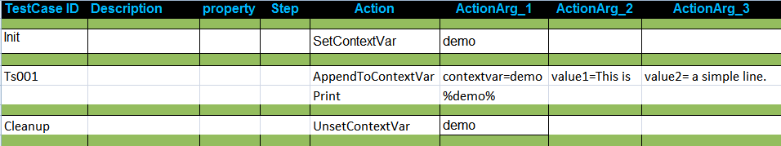
or
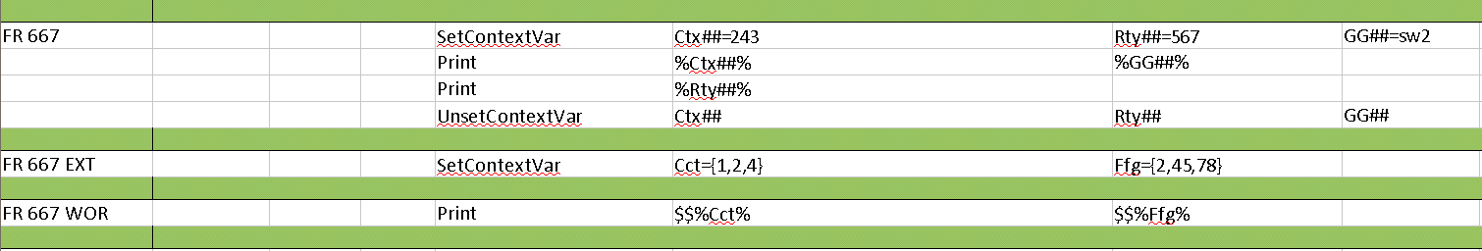

The following example show how to set a context variable, append values to the context variable and also unset the same. Here is the output of the above testcase.
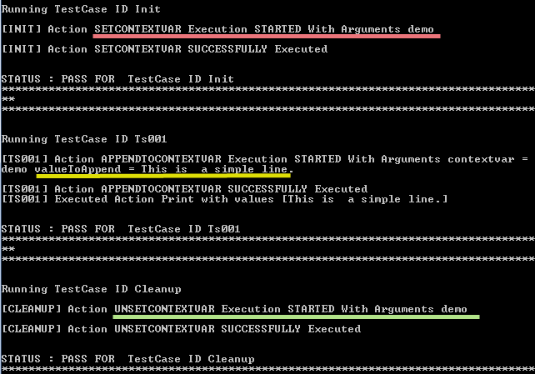

4.2 XML Parsing Atoms
These in-process atoms are part of the ZUOZ atom library, and can be used to automate testing of Web Applications. The atoms must be prefixed with Zxml. since they are dynamically loaded as a package at runtime . Please refer to the ZUOZ Reference Guide for documentation on these and other atoms.
- For further reference visit ZUG Forum.

4.3 Web Automation Atoms
These in-process atoms are part of the ZUOZ atom library, and can be used to automate testing of Web Applications. The atoms must be prefixed with Zbrowser. since they are dynamically loaded as a package at runtime . Please refer to the ZUOZ Reference Guide for documentation on these and other atoms.
- For further reference visit ZUG Forum.

4.4 Print Atom
This atom just shows the values passed to it on console. It basically can be used for debugging.

4.5 GetValueAtIndex Atom
This atom returns the value of the MVM or MVCV passed as scalar at the specific index.
GetValueAtIndex($MVM/%MVCV%,INDEX,ContextVariable)

4.6 GetCurrentIndex Atom
This atom returns the current index, starting at , of the iterator being used for the specifed MVM or MVCV passed as scalar value.
GetCurrentIndex($MVM/%MVCV%,INDEX,ContextVariable)

4.7 GetValueAt Atom
This atom returns the value of target MVM or MVCV at the position corresponding to the SourceValue in the source MVM or MVCV as scalar value.
GetValueAt($TargetMVM/%TargetMVCV,$SourceMVM/%SourceMVCV,SourceValue,ContextVariable)

5. Exception Handling

5.1 Test case or Molecule exception handling

An exception is an event, which occurs during the execution of a program, that disrupts the default sequential flow of the program's instructions. When an error occurs within a method, the method creates an object and hands it off to the runtime system. The object, called an exception object, contains information about the error, including its type and the state of the program when the error occurred. Creating an exception object and handing it to the runtime system is called throwing an exception.

In CHUR, the idea is similar, but it works slightly differently. The idea is that certain steps are designated to be cleanup actions for other actions. An example of a cleanup action for opening a file, would be closing the open file. Cleanup is a good idea to restore the state of the system, so that subsequent tests can execute from a clean state, and not be affected by previous errors.

In CHUR, cleanup actions are matched with their corresponding “initialization” actions using a step index. Thus, initialization and cleanup steps are designated in pairs, both having the same step index. Initialization step indexes increase monotonically, while cleanup step indexes decrease monotonically, thus forming nested pairs of initialization and cleanup steps.

The step column is used to designate specific actions to be either an initialization action or cleanup actions. To identify the pair, numbers are used. For a given pair, the initialization action is a numeral, postfixed by an "i" and the cleanup action is a numeral, postfixed with a "c". So, whenever an initialization step fails the corresponding cleanup action (bearing the same index) is executed.
For example, If any Atom fails in a test step which is designated with “3i” in the step column on the TestCases or Molecules worksheet of the spreadsheet, then execution will jump to the corresponding clean up step which is designated “3c ”. The scope of the initialization and cleanup pairs is within a single test case, or a single molecule.

Note that, after an exception, execution resumes at the cleanup step corresponding to the last executed initialization step. The subsequent steps may, or may not be cleanup steps (corresponding to initialization steps executed earlier).

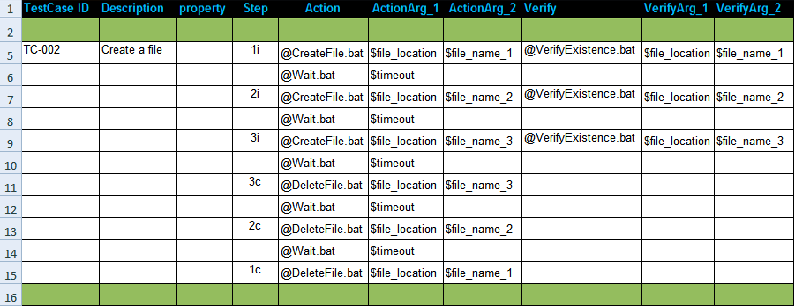
In steps 1i, 2i and 3i, we are creating three different files and also verifying their creations respectively.
Now if any steps between 1i and 2i fails, it directly jumps to 1c which deletes the first file. It simply skips the steps in between.
Similarly if any steps between 2i and 3i fails, it jumps to 2c and executes the remaining steps.

5.2 Test suite exception handling
Similar to the above section, where the issue of exception handling inside a test case or a molecule was discussed, CHUR provides the ability to initialize the testsuite, prior to executing any testcase, as well as cleanup the environment after all testcases have been executed. The purpose of the cleanup is to ensure that the machine is left in a stable and consistent state, where other testsuites can be executed properly.
For this purpose, CHUR uses two special keywords as reserved names for test cases.
A test case can be defined as an initialization test case by naming the test case as Init. This ensures that the test case is executed before any other the test cases defined in that test suite. This can be helpful if you need to create some resources, or load a database table with test data at the beginning of the execution of other test cases so that they can use the resources or data without having to create them.
Similarly, a test case can be defined as a cleanup test case by naming the test case as Cleanup. This ensures that the test case is executed at the end, even if all other test cases have failed. This can be helpful to cleanup all the resources created during the execution of the test suite.
Even though these are called test cases, and are syntactically identical to normal test cases, their outcomes are not reported. Also, unlike a failure in a normal test case, a failure in the Init test case will prevent any of the other test cases from being executed, and only the cleanup test case will be executed.

6. Context variables

6.1 Definition

Context variables are named containers that can be read and written to at run time. They are used to hold and pass information between atoms and molecules. The scope of a context variable is global (visible to all test cases) - must be declared inside the test suite.

6.2 Declaring a Context variable

To declare a context variable you need to use the SetContextVar atom in the Action column. SetContextVar is a built-in Atom that creates a context variable by the name that is passed to it as the first argument.

A value can be assigned to a context variable at the time of declaration. To do that the first argument can be replaced key-value pair

Context variables are accessible throughout the test suite and hence, if another context variable is declared with the same name, its value will be overwritten.

Context variables are different from Macros as the values of the Macros cannot be changed at runtime, by atoms of any sort. However, a context variable's value can be read or altered by atoms, or molecules.

6.3 Pass arguments by value or by reference

Once a context variable has been declared it can be passed to any atom or molecule as an argument. There are two reasons why you would like to pass context variables to an atom or a molecule as arguments. Either you want to send some information to the atom/molecule, or you want to receive some information from the atom/molecule.

When you need to send some information that is stored in a context variable, you should pass the context variable by value. The syntax to do that is to enclose the name of the context variable inside two % symbols, e.g. %BROWSER%, where the value of BROWSER could be SAFARI, and you want to send the content, i.e. SAFARI.

When you need to receive some information from the Atom, you should pass the context variable by reference. The syntax to do that, is to use the name of the context variable without any '%' signs enclosing it. e.g. PAGE_CONTENT, so the atom can return the contents of the page inside the PAGE_CONTENT context variable.

6.4 Reading and Altering Context variable value from atoms (ZUG API)

The context variables that are declared on the CHUR speadsheet can be accessed by Atoms using methods inside the ZugAPI library installed at the time of ZUG installation.

For example, to send the value of a context variable, as an argument, it should be referenced as %contextvariable%, ZUG retrieves the value of the context variable and then sends it to the Atom. So, when you pass the value of the context variable, the Atom or Molecule does not know about the actual name of the context variable used.

In contrast, if the context variable is passed by reference, then the Atom must use the ZugAPI methods to read the value of the context variable or write some value into the context variable.

ZugAPI has two methods to read from and write to a context variable:

GetContextVar is used to read the value of a context variable and AlterContextVar is used to write some value into the context variable. Here are some example of how you can access the ZugAPI methods in different languages:

Windows Platform

Ruby/Watir

ZugCOMObj = WIN32OLE.new("Automature.ZugAPI")
ZugCOMObj.AlterContextVar(ARGV[1], "MyValue")

AutoIT

$ZugCOMObj = ObjCreate("Automature.ZugAPI")
$MyValue = $ZugCOMObj.GetContextVar($NameOfContextVar)

JScript

var ZugCOMObj = new ActiveXObject("Automature.ZugAPI");
ZugCOMObj.AlterContextVar(WScript.Arguments.Item(0),"MyValue");

VB Script

Set ZugCOMObj = CreateObject("Automature.ZugAPI")
ZugCOMObj.AlterContextVar WScript.Arguments.Item(0), "MyValue"

Batch script

You can invoke functions to read or write to a context variable from from the command line using the ZUGUtility.

6.5 Zuoz pearls

Automature provides a collection of pre-built Atoms that can automate testing of a web application, fetch performance metrics, invoke web-services, etc. For more information on how to get this library, please contact support@automature.com

6.6 Appending values to a Context variable

The value stored inside a context variable is plain text and you can append more text/value to the context variable. The built-in function AppendToContextVar can be used to append values to an existing context variable.

6.7 Destroying a Context variable

To destroy (Unset) a context variable you should use the built-in function UnsetContextVar.

6.8 ZUG test environment variables

ZUG defines and maintains some global context variables. These variables may be used by the test case designer for developing test cases.

Nr | Name | Purpose | Comments
1 | ZUG_TPSTARTTIME | Timestamp when Test Suite execution started. | Value set by ZUG when the test suite execution  is started
2 | ZUG_TCSTARTTIME | Timestamp when Test Case execution started | Its value updated by ZUG when each new test  case execution started
3 | ZUG_TSSTARTTIME | Timestamp when Test Step execution started | Variable value updated by ZUG when new test  step execution started
4 | ZUG_TESTSUITEID | Test Suite Name
5 | ZUG_BASETCID | Base Test Case ID
6 | ZUG_TCID | Generated Test Case ID
7 | ZUG_TCYCID | Test Cycle ID
8 | ZUG_TCYCLENAME | Test Cycle Name | The name created by ZUG if no previous Test Cycle ID provided.
9 | ZUG_TSEXDID | Test Execution Detail Id | Value is automatically generated by the Reporting  Database for every test case execution
10 | ZUG_TESTPLANID | Test Plan ID
11 | ZUG_TOPOSET | Topology SET ID | Topology Set ID
12 | ZUG_TOPO | Topology ID | Comma Separated list of Topology ID's  participating in the Automation for testing.
13 | ZUG_TESTSUITE_TIMEOUT | Test Suite Timeout | This will contain the maximum time in seconds  for which a test suite can execute. By default its  value will be 2*60*60 seconds. One can use this  context variable to change the default behavior  of timeout dynamically during the test suite  execution.
14 | ZUG_TESTSTEP_TIMEOUT | Test Step Timeout | This will contain the maximum time in seconds  for which a test step can execute. By default its  value will be 30*60 seconds. One can use this  context variable to change the default behavior  of timeout dynamically during test suite execution.
15 | ZUG_EXCEPTION | Test Step Exceptions | If negative property is set to any Test Step then it will set this Context Variable with The error message of that Test Step and the Test will pass.
16 | ZUG_ACTION_EXCEPTION | Test Step(Action) Exceptions | If neg-action property is set to any Test Step then it will set this Context Variable with the error message of that action test step
17 | ZUG_VERIFY_EXCEPTION | Test Step(Verify) Exceptions | If neg-verify property is set to any Test Step then it will set this Context Variable with the error message of that verify test step

Example:
In the following example we show how to automate search between two destinations on a given date for a travel sit.

The macros sheet:

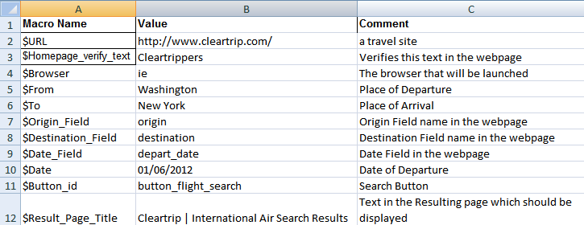

The Test case sheet:

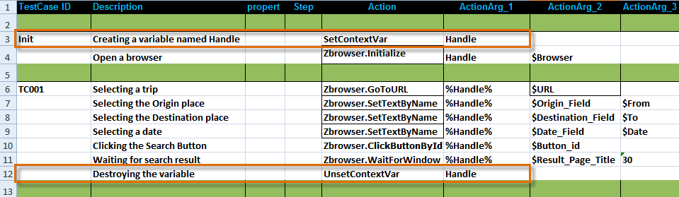
The two highlighted rows shows the declaration and destruction of a Context variable.

7. Molecules

7.1 Definition

A Molecule is a collection of several test steps describing either a complete test case, or some part thereof. It is referenced by its name and can be invoked by a test case, or another Molecule (known as a complex Molecule).

It accepts input arguments, and can also pass data back to the caller. It can invoke another Molecule, an external, or a "built-in" atom.

A molecule behaves similar to a procedure, in generic programming languages, in that, it is not expected to return anything to the caller. When a molecule fails executing an atom, its execution sequence is interrupted, and the returned to the caller.

7.2 Designing a Molecule

Molecules are designed to promote reuse of the logic of a test case. For example, the test case shown below consists of Atoms and is written on the TestCases worksheet of the spreadsheet.

A test case is implemented in a way that the logic cannot be used by other test cases. However, if we design a Molecule with a similar logic then it can be used by different test cases with an entirely different set of data, or purpose.

A Molecule is syntactically very similar to a test case. The only difference between the definition of a Molecule and a test case is that it has a Molecule ID whereas a test case has a TestCase ID. That is why TestCases worksheet and Molecules Worksheet are exactly similar except the first column that is TestCase ID or Molecule ID. Molecules also increase the readability of the Testcases worksheet.

The Molecules that are defined in the Molecule worksheet can be called by the test cases defined in the TestCases worksheet. Molecules that are defined in the Molecules worksheet can also call other Molecules defined there.

The same above test case could be written as follows:
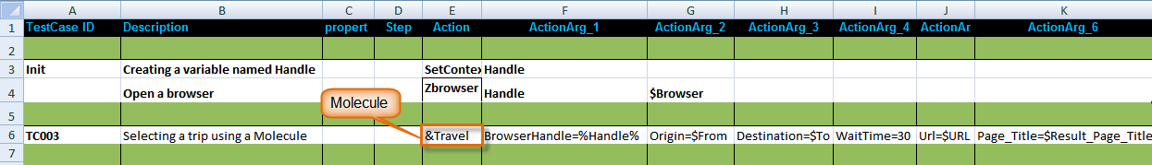

Here a Molecule Travel is defined in the Actions column along with its respective arguments.
The Molecule Travel simply does the same operations as the test case TC001 shown before.
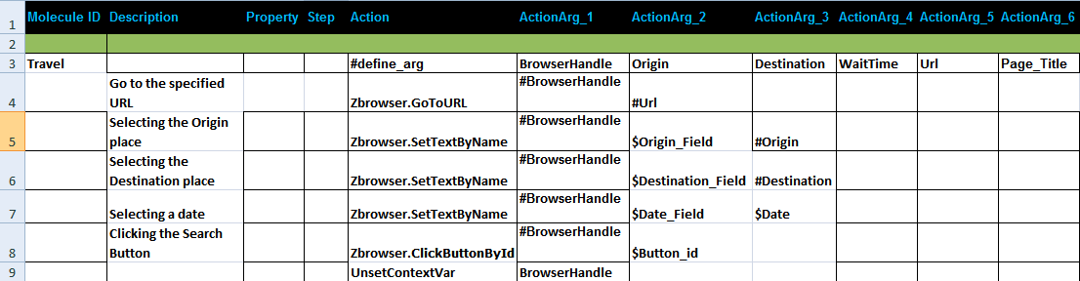

7.3 Positional and named arguments

When a Molecule is called by a test case or another Molecule, there are two different ways of passing the arguments: namely, positional argument passing and named argument passing.

Positional argument passing is the simpler way of passing arguments to a Molecule where you just specify a text value, the name of a Macro or a context variable. The Molecule can access these arguments by their positional index in the argument list.

The first row of the Molecule body must contain #define_arg as its Action step and the name of the formal arguments of the Molecule in the Action argument columns, prefixed with a #.If there are two arguments passed to a molecule, then in the molecule sheet equal number of arguments must also be defined and in

Example-

1.When the argument is a context variable that has been passed in by reference and value

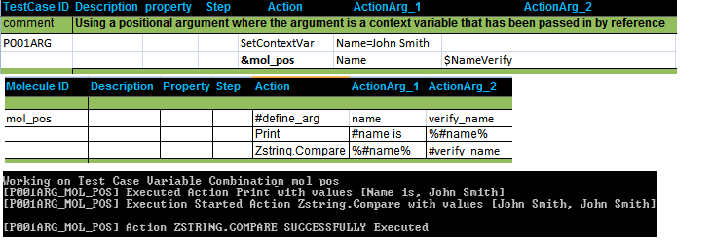
In the above example #name is passed in as reference and %#name% is passed in as value.
Hence #name=Name and %#name%=John Smith

2.Using positional argument passing,where the argument has been passed in by reference and value in a SetContextVar,

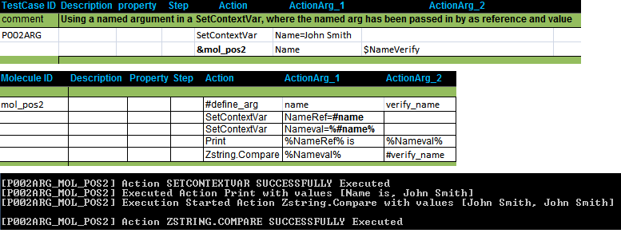

In the above example we set a context variable NameRef=#name ( passed in as reference).
Hence NameRef contains the value Name.
We also set the context variable Nameval=%#name% (passed in as value)
Hence Nameval contains the value John Smith.

3.Using an argument in a AppendToContextVar, where the named arg has been passed in as reference and value and also returns a value.

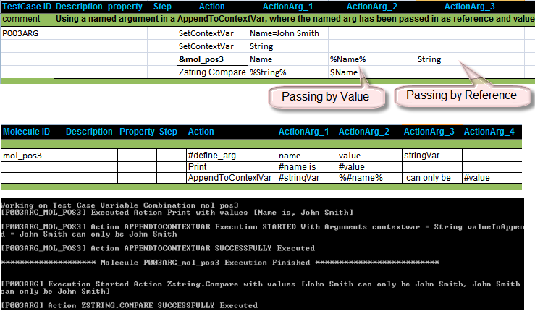

Named argument passing is more descriptive than positional argument passing as the arguments are passed as key-value pairs and hence it increases the readability and maintainability of the test case and the Molecule.

When using named argument passing, an additional row must be added in the Molecule body. The first row of the Molecule body must contain #define_arg as its Action step and the name of the formal arguments of the Molecule in the Action argument columns, prefixed with a #. The formal argument names should be used as the key in the key-value pair, when invoking the Molecule using named argument passing mechanism, as mentioned above.

When names arguments are used to invoke a Molecule, the order of arguments is not significant.

Example:
1.When the named argument is a context variable that has been passed in by reference and value
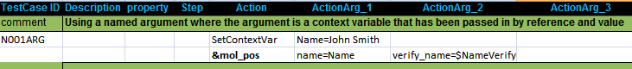
The molecule mol_pos is same as mol_positional stated above in testcase P001ARG

2.Using a named argument in a SetContextVar, where the named arg has been passed in by as reference and value

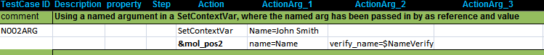
The molecule mol_pos2 is same as mol_pos2 stated above in testcase P002ARG

3.Using a named argument in a AppendToContextVar, where the named arg has been passed in as reference and value and also returns a value.
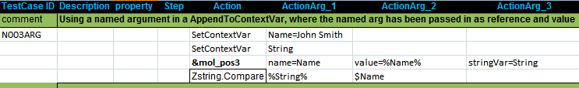
The molecule mol_pos3 is same as mol_pos2 stated above in testcase P003ARG

Please Note - Zug cannot pass a macro having key=value to a molecule using positional arguments.

Example: In the following testcase we have a macro $key_value_macro having values abc=123

Here is the molecule sheet:

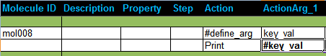
The above output does not print abc=123. Rather it prints #key_val.
To pass this macro to a molecule, Named Argument passing is needed.

8. Multi-valued Macros

8.1 Definition

Multi-valued macros (MVM) contain lists of values, e.g. $FileTypes={DOC,DOCX,PPT,XLS}, or $ITERATOR={1..10}

Multi-valued Macros are often represented by a pair of $ symbols, i.e. $$. Use of the $$ is significant only while the MVM is being referenced inside a Testcase, or a Molecule. It is not significant during declaration in the MACROS worksheet.

Lists may consist of discrete values, or sequences of values.

$ITERATOR={1..4} is equivalent to writing $ITERATOR={1, 2, 3, 4}

Multi-valued macros in CHUR offer a powerful iteration mechanism, and is a core concept. Whenever MVMs are encountered inside a testcase or a molecule, that testcase or molecule is executed multiple times, once for each value of the MVM.

8.2 Cartesian MVM expansion

Cartesian MVM expansion can be useful when all the combinations of all the MVMs present in a test case or Molecule, need to be exercised. If more than one MVM is used in a test case then a cartesian product over the set of values of all the MVMs is calculated. e.g. If there are two MVMs:

$FILE_NAME={File1.txt, File2.rtf}
$LOCATION={C:\TempFolder, \\Network\SharedFolder}

and a testcase references both these MVMs as $$ FILE_NAME, and $$LOCATION, then four test cases will be generated, one for each of the following values of these MVMs.
- [ File1.txt, C:\TempFolder ],
- [ File2.rtf, C:\TempFolder ],
- [ File1.txt, \\Network\SharedFolder ],
- [ File2.txt, \\Network\SharedFolder ]

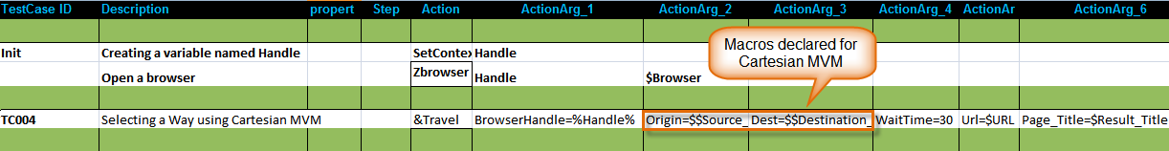
In the above example we can search all the combinations of Source to Destinations.

8.3 Indexed MVM expansion

Indexed MVM expansion can be useful when you need only the combinations of corresponding element index of another MVM. The only condition is that all the MVMs specified as an indexed MVM must have an equal number of elements. e.g. If there are two MVMs

$FILE_NAME={File1.txt, File2.rtf} and $LOCATION={C:\TempFolder, \\Network\SharedFolder}

then an indexed MVM is defined as another MVM containing the names of the above MVM, viz.

$FILE_NAME_LOCATION={$$FILE_NAME, $$LOCATION}

Note that the third MVM, i.e. $FILE_NAME_LOCATION, contains the names of the other two MVMs. This is how indexed MVMs are declared. The syntax to expand an indexed MVM is to reference the MVM which contains the names of the other MVMs to be expanded as an indexed MVM, and append the name of the MVM prefixed by a hash (#).

e.g. $$FILE_NAME_LOCATION#FILE_NAME and $$FILE_NAME_LOCATION#LOCATION will expand into two value combinations, viz.

- [ File1.txt, C:\TempFolder ],
- [ File2.txt, \\Network\SharedFolder ]

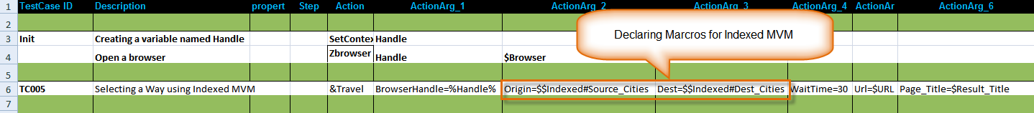
In the above example we show indexed MVM works.
We define two macros
$Source_Cities={Washington,Detroit}
$Dest_Cities={London,Liverpool}
$Indexed={$$Source_Cities,$$Dest_Cities}

The macros are called in the test case as Origin=$$Indexed#Source_Cities and
Dest=$$Indexed#Dest_Cities

The resulting search will be
i)from Washington to London and
ii)from Detroit to Liverpool.

If any Macro definition is defined as $$, e.g $$Source_Cities={London,Detroit} then Zug will show a error message
in console as
Error occured while getting the values from Macro Sheet Macros
Exception Message is Excel/GetKeyValuePair : Error occured while getting values from the macros Sheet.
Message Excel/ExpandMacrosValue: Exception raised is ..: Indexed Macros could not be found in Macro Table.: .
By changing the macro deifinition to $Source_Cities in macro worksheet of the test suite file, This error can be removed.

8.4 Nested MVMs

Not yet available.

This refers to the syntax, where the value of an element in an MVM list, is itself another MVM.

8.5 MVM used in Test-cases

When used inside the TestCases worksheet of the spreadsheet, is interpreted to auto-generate unique testcases using a new combination of values from each of the MVMs used in the testcase. Test case identifiers are automatically generated by ZUG, by concatenating the base id with the combination values. The auto-generated testcases are executed sequentially, unless otherwise specified.

8.6 MVM used in Molecules

When used inside the Molecules worksheet of the spreadsheet, invokes the Molecule multiple times sequentially, each time with a new combination of values (all executing within the context of the parent test case).

MVM used in Molecules using Named Arguments

If you are using named arguments to replace the macros in the molecules, then to use Cartesian MVM the named arguments are referenced as ##named_argument. The following example shows how cartesian MVM is used in a molecule using named arguments.
There are two Macros $MVM={value1,value2} and $MVM2={valueA,valueB}. The testcase calls a molecule which simply does cartesian product of these two MVMs.

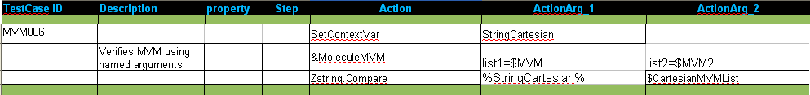

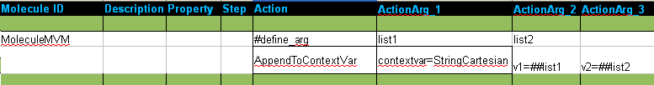

8.7 Scalar and Vector MVMs

MVMs are defined on the Macros worksheet of the spreadsheet. The syntax to declare an MVM, as we have already learned, is to prefix it with a single or a double dollar sign($$). When the MVM is used in the TestCases or Molecules worksheet, it should be prefixed with a double dollar($$) so that ZUG can expand the test case or Molecule for each value present in that MVM. This is referred to as a vector MVM.

However, if immediate expansion of the MVM is not desired, the MVM can be referred to with a single dollar sign. This allows the engine to interpret a list as a single text string value (including the braces, and the separators).

This distinction is useful when calling molecules, where the iteration needs to be delegated to the called molecule, instead of iterating the caller..

8.8 Indexing Macro values in a molecule without Indexed MVM
We can use the Index MVM feature in molecule without using Indexed MVM. The following example shows how we can perform Indexing of two MVMs passed as scalar Macro to a Molecule.
There are three Macros $TYPE={Animal,Fish,Tree,Bird} , $EXAMPLE={Lion,Shark,Oak,Pigeon} and $Cardinality={1,2,3,4} (where cardinality Macro is for number of elements in the MVMs).

First the molecule FormatList is called twice with a Macros and a Context Variable .This Molecule formats the MVM and stores it in the Context Variable as a colon separated list (such as Animal:Fish:Tree:Bird).Then the two formatted list are passed to another Molecule PrintIndexValue which also takes the cardinality Macro and performs the Indexing of the two list and then print the indexed values.

9. Multi Valued Context Variable

9.1 Definition

Multi-valued Context Variable (MVCV) contains a list of values, e.g. mvcv1={value1,value2}, or mvcv1={1..10} where mvcv1 is a context variable.

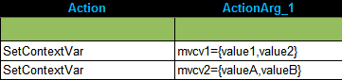

Multi-valued context variables are often represented by a pair of $ symbols, i.e. $$. Use of the $$ is significant only while the MVCV is being referenced inside a Testcase, or a Molecule. It is not required when declaring the context variable.

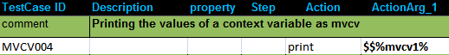

Multi-valued context variable in CHUR offer a powerful iteration mechanism, and is a core concept. Whenever MVCVs are encountered inside a testcase or a molecule, that testcase or molecule is executed multiple times, once for each value of the MVCV.
In the above example, a context variable mvcv1 was declared in the Initialization Block. The testcase MVCV004 is executed twice taking each of the values one at a time.

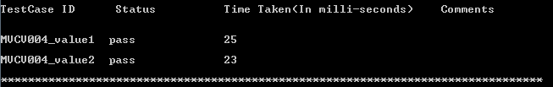

9.2 Cartesian Expansion

Cartesian MVCV expansion can be useful when all the combinations of all the MVCV present in a test case or Molecule, need to be exercised. If more than one MVCV is used in a test case then a cartesian product over the set of values of all the MVCV is calculated. e.g.
If there are two MVCVs:

mvcv1={valueA,valueB}
mvcv2={value1,value2}

and a testcase references both these MVCMs as $$%mvcv1% and $$%mvcv2%, then four test cases will be generated, one for each of the following values of these MVCVs.
- [ valueA,value1 ],
- [ valueA,value2 ],
- [ valueB,value1 ],
- [ valueB,value2 ]

The above testcase will be executed 4 times -

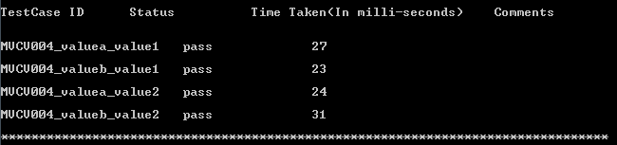

9.3 MVCV used in Test-cases

When used inside the TestCases worksheet of the spreadsheet, is interpreted to auto-generate unique testcases using a new combination of values from each of the MVCVs used in the testcase. Test case identifiers are automatically generated by ZUG, by concatenating the base id with the combination values. The auto-generated testcases are executed sequentially, unless otherwise specified.

9.4 MVCV used in Molecules

When used inside the Molecules worksheet of the spreadsheet, invokes the Molecule multiple times sequentially, each time with a new combination of values (all executing within the context of the parent test case).

MVCV used in Molecules using Named Arguments

If you are using named arguments to replace the MVCVs in the molecules, then to use Cartesian MVCV the named arguments are referenced as ##named_argument. The following example shows how cartesian MVCV is used in a molecule using named arguments.
There are two MVCVs defined in the Init block : mvcv1={value1,value2} and mvcv2={valueA,valueB}. The testcase calls a molecule which simply does cartesian product of these two MVCVs.

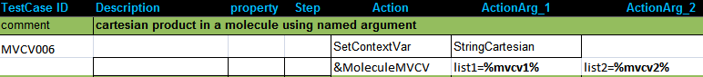
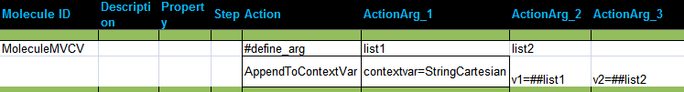

In the above example we have passed the values of the context variables as %mcvc1% and %mvcv2% to the molecule MoleculeMVCV. These values are then expanded in the molecule using ##named_argument.
The following example shows how to use MVCVs when passed as reference to a molecule.

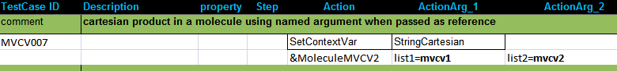
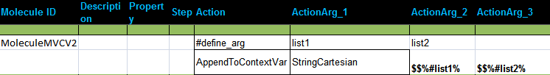
It gives the same output for both the testcases.

9.5 Scalar and Vector MVCVs

MVCVs can be defined on the Testcase and Molecules worksheet of the spreadsheet. The syntax to declare an MVCV, as we have already learned, is to prefix it with a single or a double dollar sign($$). When the MVCV is used in the TestCases or Molecules worksheet, it should be prefixed with a double dollar($$) so that ZUG can expand the test case or Molecule for each value present in that MVCV. This is referred to as a vector MVCV.

However, if immediate expansion of the MVCV is not desired, the MVCV can be referred to without any dollar sign. This allows the engine to interpret a list as a single text string value (including the braces, and the separators).

This distinction is useful when calling molecules, where the iteration needs to be delegated to the called molecule, instead of iterating the caller.

Look at the following example-

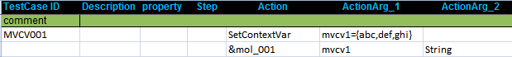
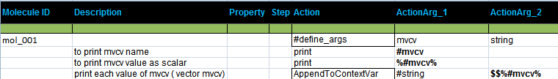

10. Concurrent Execution

CHUR allows test cases, as well as Molecules to execute concurrently. Concurrent execution can be specified in multiple ways, viz.

10.1 Test case or Molecule concurrency

Property is a column in the Testcases and Molecules worksheets, which allows the testcase designer to specify the properties of a test case or a Molecule. Multiple properties may be specified as a pipe separated list. GCE, which is an abbreviation of Generate Concurrent Execution, is a test case or Molecule property. It means that if a test case or a Molecule contains an MVM (Multi Valued Macro), and the property column specifies GCE, then the test case (or the Molecule) will be expanded for each combination of the MVMs and will run them concurrently (i.e. in parallel) instead of sequentially.

10.2 Test step concurrency

Step is a column of the Testcases and Molecules worksheets. This relates to each Action of a Test Case or a Molecule (but) does not apply to a Verification step. It should normally be a monotonically increasing number for each test case action. If two or more actions of a test case/Molecule have the same step number, then these steps may be executed concurrently.

10.3 Thread safe context variables

CHUR does not support the notion of scope, so, different threads creating or updating a context variable with the same name would conflict with other existing variables. To get around this, CHUR supports the notion of a thread specific instance of a context variable. It is the responsibility of the Test Suite designer to create and use thread specific context variables, when appropriate.

A ## (double hash) appended to the name of a context variable, automatically refers to the context variable with the thread id appended to the name, thus creating a unique instance of the variable. When a thread specific context variable is referenced in the main thread, ## equates to a null string.

10.4 Passing thread safe context variables as arguments

We refer to a thread safe context variable, for the purposes of argument passing in the following ways, viz

context_variable_name## - this is a thread specific instance of the context variable. CHUR will automatically replace ## with the thread id. This is equivalent to the scheme of passing by reference, except that CHUR will pass the thread specific name of the context variable.

%context_variable_name##% - this is the value of the thread specific instance of the context variable. CHUR will automatically replace ## with the thread id and retrieve the thread specific value of the context variable.

11. Negative Testing

11.1 Definition
Testing the system using negative data is called negative testing, e.g. testing the password where it should be minimum of 8 characters so testing it using 6 characters is negative testing.

11.2 How To Use
To use any test step as a negative testing, put the word “negative” in property column. Irrespective of testcase sheet or molecules sheet , this feature can be used. This negative testing feature will only work for atoms not for any molecule. When the atom fails and shows the Exception in console if negative property is set to it, then ZUG_EXCEPTION context variable will be set with the Exception message and the test step will pass.
We can put “neg-action” for testing an action step and “neg-verify” for testing a verify step. They will set exception messages separately in ZUG_ACTION_EXCEPTION and ZUG_VERIFY_EXCEPTION.
Example-
In the following test case, we are doing negative testing for Compare atom by giving incorrect number of arguments. The error given by Zug is stored in the context variable ZUG_EXCEPTION (which is an in-built context variable). In the next test step, we are checking whether the error thrown was Argument mismatch or not.
To be noted –
If we call a molecule in a test case stating negative property beside the molecule, the test case will fail. The negative property works only for test steps.
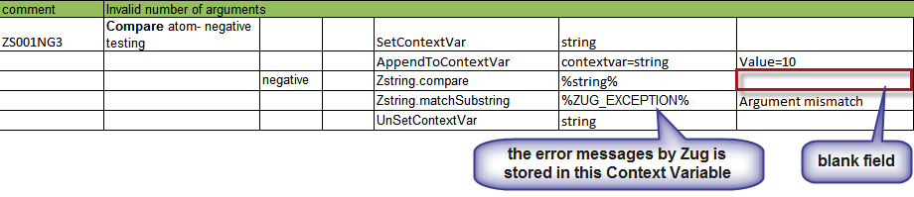The following figure shows the various outcomes of a test step for different properties of Zug.
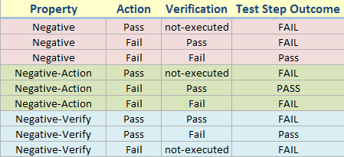
Example:

In the following test case, we have used the Negative property and have deliberately made the action and verification to fail. Even though the action and the verifications fail, the status of the test case is pass.

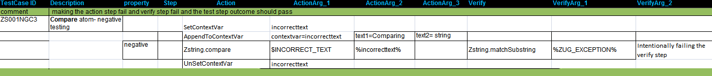
(Enlarge to view)
In the next example, we have used the Negative-Action property and have deliberately made the action fail and then verify that the correct error message is displayed. The status of the test case is pass.

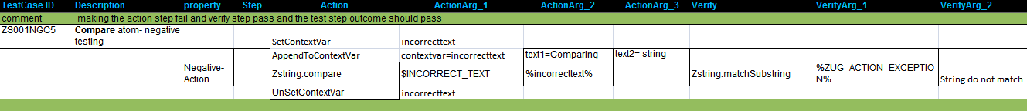
(Enlarge to view)
In the next example, we have used the Negative-Verify property and have deliberately made the action pass and verification fail. The status of the test case is pass.

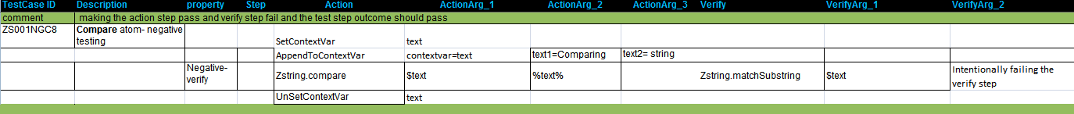

12.NameSpaces

ZUG supports the inclusion of external worksheets that contain Macros, Prototypes or Molecules. Since, such inclusions can potentially lead to conflicts in names, imported names are placed inside specially named containers, called namespaces. All names declared within a namespace must be unique, and are referenced by prefixing the name of the entity with the name of the container, where it is defined.
Namespaces promote reuse of Molecules, and atoms, by providing libraries of pre-built containers.
To call the Molecules use '&' sign and to call the macros use '$' sign before the namespaces. For instance, to refer to an external Macro you should write $Spreadseet_Name.Macro_Name and to refer to an external Molecule you should write &Spreadsheet_Name.Molecule_Name, where Spreadseet_Name is the name of the external spreadsheet file, where the macro, or the molecule has been defined.

Zug can include multiple external files from the Config Sheet.
To call any molecule or any macro from an external file, the external file must be included in the Config sheet first.
Example -


12.1 Calling a Molecule from a single external worksheet.

The following example shows how to call a Molecule from an external file (which is IncludeFile.xls.)

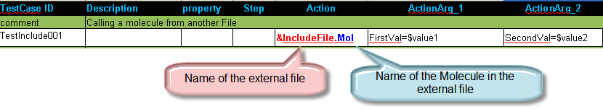
The macros $value1 and $value2 are passed to the Molecule Mol which is written in IncludeFile.xls spreadsheet. Here is the snapshot of the molecule sheet in the external file. It simply compares the two values passed from the testcase.
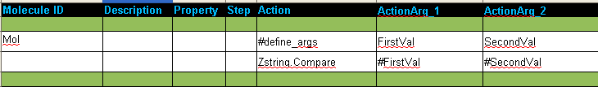

12.2 Calling external macros from an external worksheet.

The following example shows how to call two external macros from an external worksheet (which is IncludeFile.xls.)

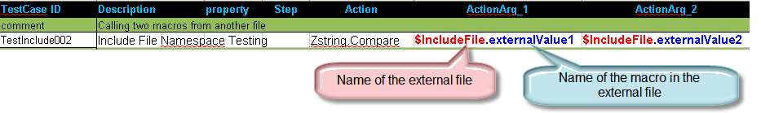
The macros $externalValue1 and $externalValue2 are written in the macros sheet of the external sheet IncludeFile.xls.

12.3 Calling two different macros from different external worksheets.

The following example shows how to call two external macros from from two different external worksheet (which are IncludeFile.xls and ThirdIncludeFIle.xls) The IncludeFile.xls contains $externalValue macro in the macros sheet and the ThirdIncludeFile.xls contains $extValue in its macros sheet. Here we compare these two macros written in different files in a single testcase.

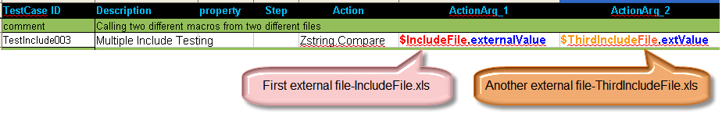

12.4 Multi Level Include Files
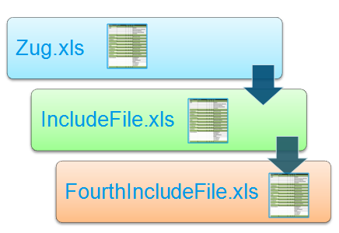
Zug can include files in Multi level. i.e. Zug can include an external file which can again include another external file. In the followling example we have used three test suites.Zug.xls contains the testcase which calls upon a molecule Mol2 in the IncludeFile.xls. The molecule Mol2 calls upon another molecule Mol in the FourthIncludeFile.xls. The config sheet of Zug.xls includes the IncludeFile.xls but not FourthIncludeFile.xls. The IncludeFile.xls includes the FourthIncludeFile.xls

Here is the snapshot of the testcase written in Zug.xls file. It calls the molecule Mol2.
Here is the snapshot of the molecule Mol2 written in IncludeFile.xls file. It calls the molecule Mol2.
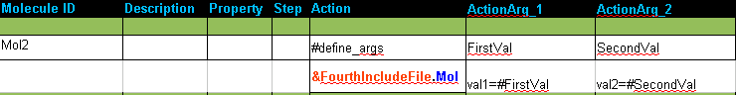
Here is the snapshot of the molecule Mol written in FourthIncludeFile.xls file. Here val1 and val2 contains the values of the macros $value1 and $value2 written in the Zug.xls file.
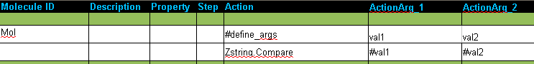

13. Command Line Options
ZUG supports various command line options. Some of them are

13.1 -verbose
-verbose option is used to display the execution result of the test suite in the console.

13.2 -include
As we have seen that we can include test suite by providing test suite's file name or path name along with the file name in the config sheet. Another way of including test suite is by including test suites at run time using the -include command line option .We can include multiple test suites from command line using the -include option. The test suites mentioned in the -include option must be separated by a comma. For example
>runzug E:\testsuites\testCMDInclude.xls -verbose -include=IncludeS2.xls,IncludeS1.xls
Here IncludeS1.xls and IncludeS2.xls are being included at runtime.Thus it provides a dynamic way of including test suites.Also the files included from command line has a higher prioirty over the files included from the config sheet.If a file is is mentioned in the include section of config sheet and a file with same name is being included from command line then the file mentioned in the config sheet is discarded and the one included from command line is used in the execution.
One more powerful feature of this option is to provide name spaces to the test suite included from command line(run time).The default name space of a test suite is the name of the test suite file .Consider the above example ,in this case the name space will be testCMDInclude. However ZUG provides another way of giving name space to the test suites included at run time .We can override the default name space of a test suite included at run time using the -include option. The syntax for giving name space in the -include option is
-include=namespace1#filename1,namespace2#filename2
where the file name can be either a file name or file path along with the file name.

13.3 -macrocolumn
We can have multiple value column in a test suite for a macro .At run time we can select a particular column
using the -macrocolumn option. The syntax for -macrocolumn is
-macrocolumn=file identifier:column number, file identifier:column number
where the file identifier is the file name,default name space or the optional name space provided in the -include option. If we have provided any optional name space in the -include option then it should be the file identifier in the -macrocolumn.
If any cell of the selected column is empty then it takes the value of the default column cell(1st column i.e, the “value” column).For example if we run the above test suite by giving option in the -macrocolumn to choose the 2nd column of the macro value then the substituted value of $field will be {username,password}.

14. ZUG Logs
ZUG records output from the test suite execution in different text files. The files are stored in the default location (%appdata% under Windows) in a directory called ZugLogs in case of Linux it is saved under home/<users> directory with the same name. The log files can be archived in a central repository, accessible to Zermatt. Please refer to Zermatt User Manual for details on how to configure the location of the archive.

14.1 Result Log
This log records the console output, and contains the sequence in which test cases have been executed, the specific molecules and atoms that were invoked, along with the actual arguments that they were invoked with.

14.2 Debug Log
This log is for Automature's internal use only.

14.3 Error Log
This log contains a summary of any errors encountered by the atoms and molecules during test case execution.

14.4 Primitive Log
This log contains information specifically written by the executing atoms. Atoms can choose to provide custom trace information, or other useful output regarding their execution, using the ZugAPI's logging method.

15.Using External Atom Framework(Atom Libraries)
We can also call external atom libraries or atom frameworks from CHUR. These external atoms when invoked from ZUG are run as In-Process atom. For this to work we give ZUG some extra configuration settings. In the ZugINI.xml we have to provide the location and some configuration detail of a Wrapper. This wrapper provides a layer of abstraction for the CHUR programmers and give them the freedom to concentrate more on designing and writing test cases without thinking too much of about how the atom is implemented. Given the signature of the atom we can use the services of that atom without bothering about any other information. Below given is the snap shot of the ZUGINI.xml in which the configuration of the Wrapper is given.

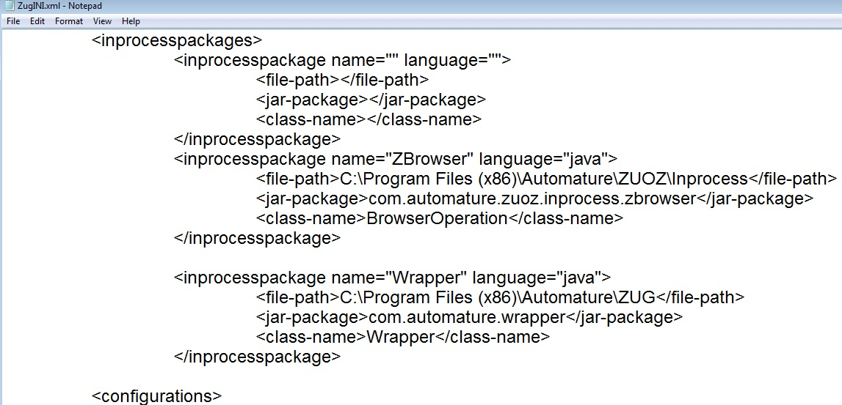
Note:In short and simple we can call any method of a class(for now its restricted to java class) if we know the signature of the method.
Now the convention for using the Wrapper in the test suite is “ Wrapper.alaisname.atomname ” ,here the Wrapper is the keyword,alias name is a name given to a particular class in the wrapper.txt (the configuration file whose role is described later in the topic) and the atom name is the name of the atom to be invoked of that particular class. Now if the atom invoked return's some thing ,the returned contents are stored in a context variable which is passed as the last argument of the atom. If the atom returns a simple text then the text is stored in the context variable and if it returns a complex object then a handle to that object is returned in the context variable which can be used further to pass as an argument to another atom or to call the atom of that particular object if needed.
When we call an atom of a class for the first time we send “none” as the first argument ,seeing the none keyword the wrapper creates an object of that class. The handle to the that object is then stored in the context variable which is passed as last argument of the atom(if the atom does not return any thing) or as the second last argument(if the atom returns any thing).
Now using this wrapper we'll write test suite that uses external atom framework's atoms. Below given is sample test case for using external atoms of an atom framework. In the given test case we are using some rest services
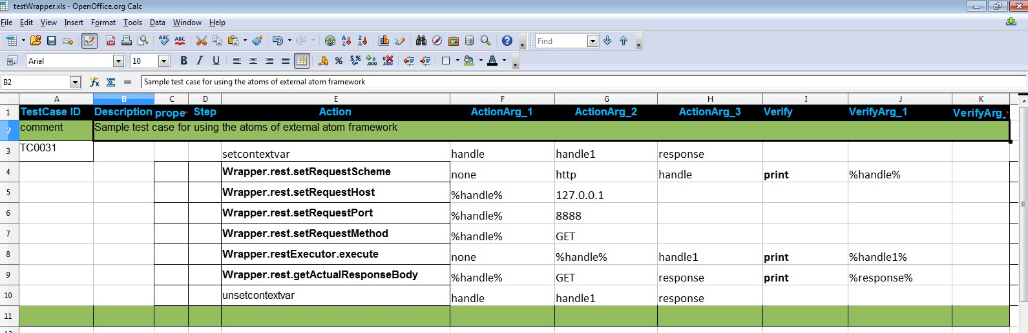
Here we have used two class rest and restExecutor. In the second test step we are calling an atom setRequestScheme of the rest. The setRequestScheme atom's signature does not return any thing. But since we are creating an object of the rest by sending “none” as the first argument it will return the handle of that newly created object in the context variable handle which is passed as the last argument. In the third ,fourth and fifth test step we are setting the value of the rest object (which was created in the 2nd test step) by sending the handle of that object as the first argument.
Similarly in the fifth test step we are calling the restExecutor's execute atom and passing the rest object as an argument and since we are creating an object of the restExecutor by sending none as the first argument it will return the object handle in the handle1 context variable.
The execute atom set some data values of the rest object that is passed to it that we are retrieving in the next step by calling the getActualResponseBody of that rest object. This atom returns a text which is stored in response context variable and in the verification section we are just printing the value of response context variable
Below is the console output of the execution of the above test suite
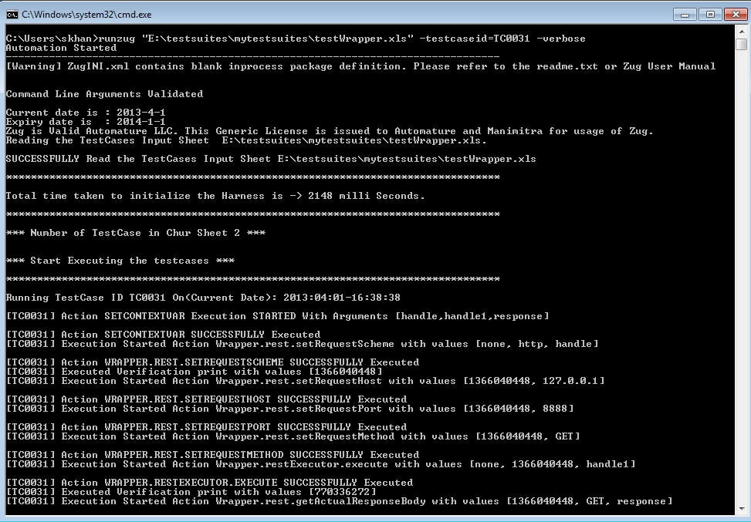

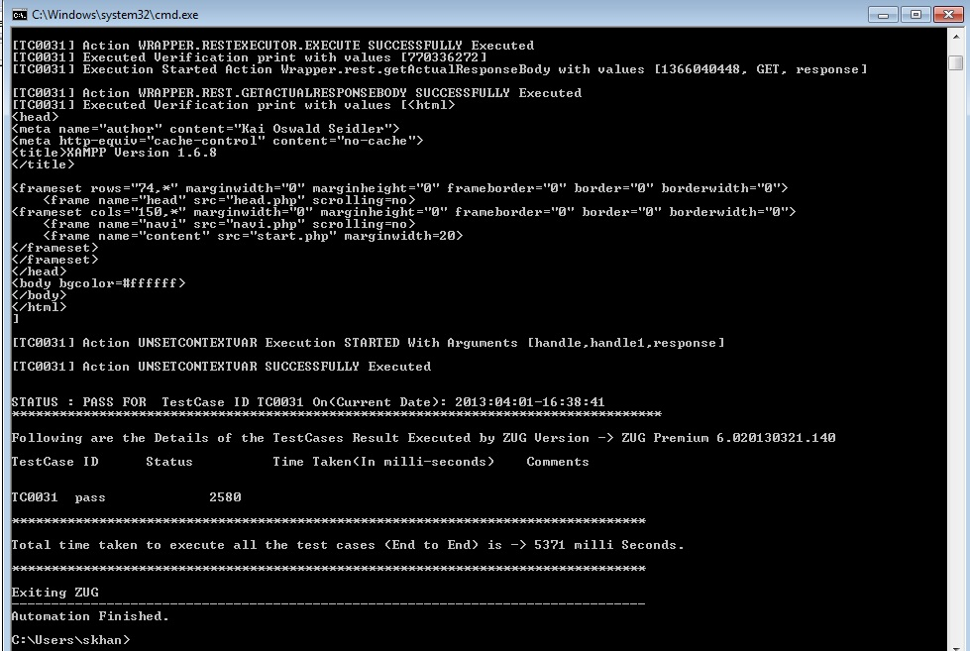
Configuring Wrapper.txt:
To use the services of external atom frame work we must configure an additional configuration file called wrapper.txt. It is a configuration file which is used by the Wrapper. This file holds the mapping of the alias name (to the fully qualified class name) along the with path to the external atom framework and some other information in a key=value format. Given below is the snap shot of a sample wrapper.txt for the above example test suite
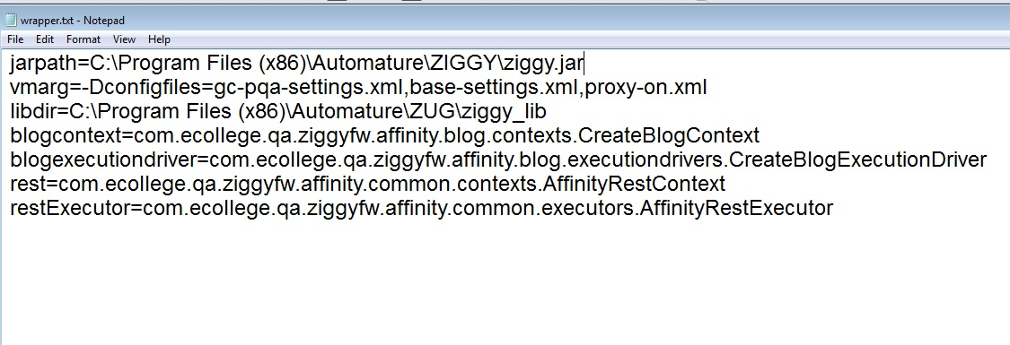
The jarpath is the key whose value is the path to the external framework jar.vmarg is the runtime argument to the VM.libdir is used in case if we want to include some other external jar file. Its value is the path to the directory where all the jar files are placed.The rest are the alias names along with thier mapping to the respective classes.

16. Reporting test results

DAVOS is Automature's Webservices interface into ZERMATT, the Planning and Reporting Tool. Normally, test case designers need not be aware of the existence of DAVOS, since ZUG - the engine handles the reporting of test cases written in CHUR implicitly.

Under special circumstances, if the testcase needs to store special data, then DAVOS webservices atoms provide a mechanism for doing so. For more information on this, refer to the DAVOS Reference Manual.

To report to the database you need to configure the “configsheet” of your test suites.
If you the mandatory fields are not set and still you want to report to database then it will prompt for the database user name and password credentials.
To report you need to provide the command line switches of ZUG viz. -testplanid -topologysetid. These switches are mandatory for reporting.

17. Glossary

Action Arguments
The behavior of an action can be modified by sending it certain extra information. This extra information is sent as a list of “arguments”.
Action Step
A test case is a sequence of one or more Actions. An Action may be a Test Action, or a Verification Action. Each Action may take as many arguments as necessary. Actions carry out the logic of a test case, and also can be used to verify the outcomes of Test Actions.
Atom
Atoms are the basic units of execution in CHUR. They are entities, such as programs or scripts that may be executed at a command line level in a shell (e.g. the Command Prompt in Windows, or bash in Linux). Atoms may be invoked from the Test Cases or Molecules worksheets in the Test Suite spreadsheet. An example of an atom can be a program that enters text into a form field inside a web page, or can simulate a button click. In CHUR atoms are prefixed with the sign @.
Example: @ClickLinkByHref.rb
In this example ClickLinkByHref.rb is an atom written in Ruby, that allows the testcase to click on a link contained in a web page. Atoms can take any number of arguments, to qualify their action.
An atom is expected to return an exit status code that implicitly tells ZUG if the action was successful. By convention, a non-zero status is interpreted as a failure. When ZUG encounters a failure status, it automatically invokes the appropriate clean up steps specified in the CHUR spreadsheet for the corresponding test case.
Exceptions
In CHUR, when atoms return an error, an exception happens, causing sequential execution to be suspended, and cleanup actions to be performed. When a molecule encounters an exception, control is transferred back to the calling molecule, or test case, after executing the cleanup steps inside that molecule. When control is transferred back, execution does not resume sequentially. Instead, the caller's cleanup steps are executed. When a testcase encounters an exception, the testcase's cleanup steps are executed, and then the next test case is started.
Molecule
Molecules are a collection of atoms, or other Molecules, in a sequence, with the added ability to express more complex logic. Molecules may call atoms directly, or through other nested Molecules. Test Cases, themselves could be considered Molecules themselves, except that no other test case or Molecule can call them. Example of a Molecule can be to simulate a user login, by using the atom in the example above. In CHUR Molecules are prefixed with the sign &
Example: &TwikiLogin
Note that, Molecules, unlike atoms, can only be executed within ZUG. Also, Molecules do not return any exit status.
Namespace
CHUR allows test case designers to reuse test logic and data. Reuse involves the ability to package and distribute reusable molecules and macros in separate spreadsheet files, and referenced from the spreadsheet where the test cases are specified. Since names used in such distributions may not be unique, and therefore cause unexpected behavior, CHUR uses the concept of Namespaces, to make names unique. Therefore, when referring to an entity, such as a macro, or a molecule, that is defined in an external file, the name must be prefixed with the name of the file, where the entity is defined. This allows names, that are unique within the file, to be also globally unique.

Property
Testcase and molecules can have associated properties, that can be used to control certain behavior. Propeeties can be used to tell the engine to execute these entities in specific ways, e.g. Concurrently, or sequentially.
Test Case
A test case is a collection of steps whose purpose is to verify a certain feature of a product. Test-cases are the smallest units of reporting about the execution of tests.
Test Cycle
During the course of a project, multiple test sessions may be executed, related to a single test plan. These sessions would have several attributes in common, but some may differ. Usually, the difference would be the build of the product under test. These sessions are known as Test Cycles.
A Test Case would record only one result within the scope of a single test cycle. Multiple executions of the same test case within a single cycle, would overwrite previous results. ZUG, unless specifically requested to do otherwise, always creates a new test cycle, each time a test suite is executed.
Test Plan
A test plan is a plan of how a set of features shall be tested within the scope of a project schedule. A Test Plan is defined in Zermatt, and provides a context within which the test outcomes may be stored. Note that Test Plans are only relevant if the results are expected to be stored.
Test Step
A test case is a sequence of one or more Steps. A Test Step corresponds to a single row in a spreadsheet, that is not empty, or a comment. A test step results in an invocation of an Atom or a Molecule. A test step may be explicitly enumerated. If enumerated, it should be a monotonically increasing number for each step. If two steps of a test case are given the same number, then the two steps are intended for concurrent execution.
Some of these steps may be designated initialization steps, others may be designated to be cleanup steps. The numbers are post-fixed with the letters “i” or “c” respectively. Unless they are explicitly designated to be such, test steps are understood to be normal actions carrying out the logic of the testcase.
Test Steps may implement two kinds of logic. The logic may be integral to the execution of the test itself, or it may verify the intermediate or final state of the system under test.
Test Suite
A test suite is a collection of test cases, grouped according to some criteria, such as a related set of requirements. In CHUR, a test suite is represented by a single spreadsheet file, containing one or more test cases. The test suite file may make use of other files, where additional dependencies may have been specified. However, the test cases themselves must reside in a single file.
Verification Step
Each Action of a Test Case may consist of none, one, or several Verification steps. Verification Steps may reference verification Molecules or verification atoms. And each Verification step may take several arguments as needed. As with other atoms, verification atoms are also expected to return an exit status code that implicitly tells ZUG if the verification was successful. By convention, a non-zero status code is interpreted as a failure. When ZUG encounters a failure status in verification, it automatically invokes the corresponding clean up steps.
In CHUR, verification actions, and their corresponding arguments, are identified by a set of columns explicitly set aside for this purpose.
Verification Arguments
The behavior of a verification can be modified by sending it certain extra information. This extra information is sent as a list of “arguments”.

Note that one action may have more than one verification step. Though it may increase readability if the steps were packaged as a molecule, and invoked as a single step, CHUR allows multiple verification steps to be specified inline, on consecutive rows, under the Verify column.
The ZugUtility provides a command line interface to invoke methods inside the ZugAPI
Auto-generated testcases can also be executed concurrently, when the GCE property is set for the testcase.
Auto-generated molecules can also be executed concurrently, when the GCE property is set for the molecule.
Auto-generated testcases can also be executed concurrently, when the GCE property is set for the testcase.
Auto-generated molecules can also be executed concurrently, when the GCE property is set for the same.
The number of threads available for concurrent execution, is a global setting. The concurrent execution of test steps or test cases is limited by the number of threads available. When the threads are exceeded, execution is sequentialized.

